**Logging using SLF4J**

**Exercise 1: Logging Error Messages and Warning Levels**

**Task:**

Write a Java application that demonstrates logging error messages and warning levels using SLF4J.

**Step 1: Add Dependencies in pom.xml**

Add the following dependencies inside the <dependencies> section of your pom.xml:

<!-- SLF4J API -->

<dependency>

<groupId>org.slf4j</groupId>

<artifactId>slf4j-api</artifactId>

<version>1.7.30</version>

</dependency>

<!-- Logback Classic (SLF4J implementation) -->

<dependency>

<groupId>ch.qos.logback</groupId>

<artifactId>logback-classic</artifactId>

<version>1.2.3</version>

</dependency>

Also, add the following plugin inside the <plugins> section of your pom.xml to allow execution of Java classes:

<!-- Exec plugin to run Java classes with main() -->

<plugin>

<groupId>org.codehaus.mojo</groupId>

<artifactId>exec-maven-plugin</artifactId>

<version>3.1.0</version>

<executions>

<execution>

<goals>

<goal>java</goal>

</goals>

</execution>

</executions>

<configuration>

<mainClass>com.example.LoggingExample</mainClass>

</configuration>

</plugin>

**Step 2: Create Logging Class**

Create a Java file: LoggingExample.java

package com.example;

import org.slf4j.Logger;

import org.slf4j.LoggerFactory;

public class LoggingExample {

private static final Logger logger = LoggerFactory.getLogger(LoggingExample.class);

public static void main(String[] args) {

LoggingExample example = new LoggingExample();

example.startProcess();

example.processData(null); // triggers warning

example.endProcess();

}

public void startProcess() {

logger.info("Starting the process...");

}

public void processData(String data) {

if (data == null) {

logger.warn("Data is null, using default value");

data = "default";

}

try {

int result = 100 / data.length();

logger.info("Processed data length ratio: {}", result);

} catch (Exception e) {

logger.error("Error processing data", e);

}

}

public void endProcess() {

logger.info("Process completed.");

}

}

**Step 3: Run the Application**

Run the LoggingExample.java class from your terminal using the following command from the project root:

mvn compile exec:java

**Output:**

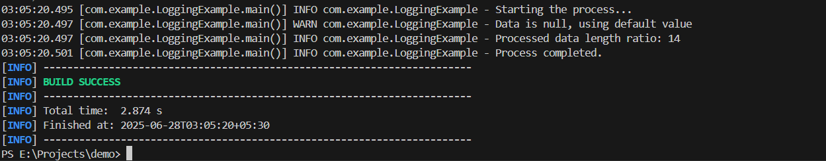

**Conclusion:**

* Demonstrated use of INFO, WARN, and ERROR logging levels.
* Used real-world methods to simulate a process with logging feedback.
* Captured runtime errors and handled null values with logging.